**2.3 client-server architecture**

**Name _____________ class______________**

The website www.checkyourwellbeing.com offers help and advice about personal well-being.

The website has a link – ‘Calculate my BMI’ – that users can click to work out their ‘Body Mass Index’.

When the ‘Calculate my BMI’ link is clicked on the client computer, this webpage is requested.

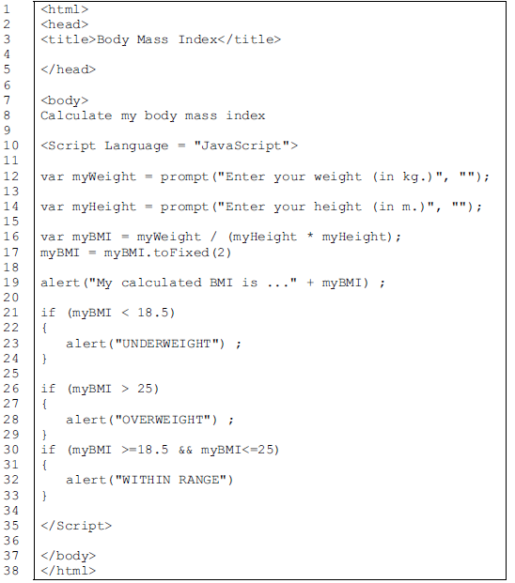

Loading the webpage produced this sequence of dialogue boxes:



(a) Which lines in the webpage script are JavaScript code?

__________________________________________________________________

(b) (i) Give the identifiers of two variables which have been used by the programmer.

1 __________________________________________________________________

2 __________________________________________________________________

(ii) What group of program statements are performing selection?

line number__________________ up to line number ______________________

(c) By studying the web page script and its use, what is the use in JavaScript of:

(i) the prompt function?

__________________________________________________________________

__________________________________________________________________

__________________________________________________________________

(ii) the alert function?

__________________________________________________________________

__________________________________________________________________

__________________________________________________________________

(d) The diagram shows the client computer network with the connection to the Internet.

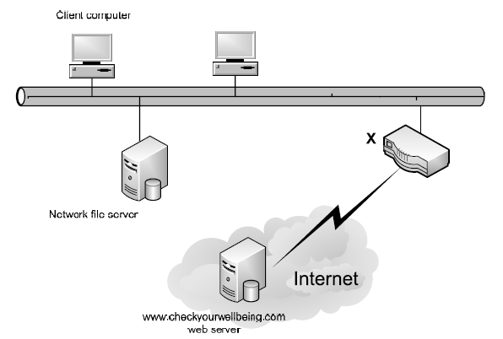

What is the hardware device labelled X?

__________________________________________________________________

(e) Put five of these statements in the correct sequence to describe how the content of the page shown is displayed by the client computer’s browser software.

Two of the statements will not be used.

A. The client computer processes the JavaScript code.

B. The page content is transmitted to the client computer.

C. The page is displayed on the client computer.

D. The user clicks on the hyperlink and the web page is requested from the network file server.

E. The web server processes the JavaScript code.

F. The user clicks on the hyperlink and the web page is requested from the

www.checkyourwellbeing.com web server.

G. The server finds the web page.

The sequence is: (fill in the letters)



(f) How is this JavaScript code run?

___The browser has an interpreter to execute the JavaScript code. _______________________________________________________________

__________________________________________________________________

(g) The web developer tested the JavaScript code without involving the web server.

Explain how this is possible.

___The developer can load the page from the local hard drive and test it with the interpreter offline._______________________________________________________________

__________________________________________________________________

1. lines 10 – 35
2. (i) myWeight – myHeight – myBMI

(ii) Line Number 21 – 33

(c) (i) prompts the user for input assigns the input to the given variable

(ii) displays the text shown in a dialogue box with the alert symbol

(d) router

(e) F – G – B – A – C

(f) The browser will have an interpreter to execute the JavaScript code.

(g) The browser loads the page from the local hard drive.